**Pashto Learning Software (PukhtoIzdakkra)**

February 28, 2013

**Group 10**

Aakif Sultan – 14100136

Danish Jalil – 14100109

Quratulain Zahid Sheikh – 14100146

Zarmina Khan – 14100205

**Contents**

**1 Introduction**

1.1 Purpose

1.2 Scope

1.3 Overview

1.4 Definitions

**2 General Descriptions**

2.1 Product Functions

2.2 User Characteristics

2.3 Assumptions and Dependencies

**3 Requirements**

3.1 Functional Requirements/ Use Cases

3.1.1 Database Requirements

3.1.2 Tutorial Requirements

3.1.3 Game Requirements

3.2 External Interface Requirements

3.2.1 User Interfaces

3.2.2 Hardware Interfaces

3.3 Performance Requirements

3.4 Attributes

3.4.1 Availability

3.4.2 Security

3.4.3 Maintainability

**CHAPTER 1**

**1.1 Purpose**

This document describes the software requirements for Pashto learning software. All the specifications are for all the people involved in this project.

**1.2 Scope**

This software is responsible for teaching basics of Pashto language and making sure that the user actually learns it.

**1.3 Overview**

The rest of document is divided into following parts:

* Chapter 2 has general description about the software
* Chapter 3 has all the requirements and software characteristics

**1.4 Definitions**

* Pashto:

Pashto is the native language of Pakhtuns. The aim of this project is to teach Pashto, by using

English words and their respective translated Pashto words.

* Module:

A module is a small individual unit that combines with other similar modules to form a complex structure. This software is divided into 11 modules, each having its own type of words. They are:

‘Counting’, ’Basics’, ’Relations’, ‘Body Parts’, ‘Adjectives’, ‘Nouns’, ‘Verbs’ , ‘Colors’ , ‘Animals’,

‘Questions’, ‘Challenging Sentences’

* Touch Android:

One of the properties of Android Smart phones is ‘TOUCH’. Users interact with their phones by touching icons on their phone screens. Users will give input by using touch and clicking on buttons to continue their learning.

* Tutorial:

An instructional program that is responsible for tutoring. Users will be learning Pashto from these tutorials.

* Sound clip:

A sound clip is a short segment of media, which will be used in this project as a means of information. Each word will have its respective pronunciation in the form of a sound clip.

* Mini-Games:

Mini-games are small interactive games that will be used as quizzes. Each module will have a quiz in the form of a mini-game, at the end. Users will have to play them to unlock other modules. They will also be used to prevent users from getting bored.

**CHAPTER 2**

**2.1 Product Functions**

‘PukhtoIzdakkra’ is Pashto learning software, divided into different modules. Each module will have its own type of words, which the user will actually have to learn in order to unlock a new module. Games at end of each module act as quizzes that will judge the user’s performance. This app first asks user to sign up. With the help of a unique username, he is given a user account that will store his points and the number of modules he has passed. While in a module, he will be able to see a list of related words in English. On clicking any of those words, a dialogue box will open that will display the word in English and Pashto, and a button named ‘Pronunciation’. User will click on this button to hear the pronunciation in Pashto as well.

**2.2 User Characteristics**

This is a single-user based application.

**2.3 Dependencies**

* + User should have a smart phone having an Android operating system.
  + User must know English.

**Chapter 3**

**3.1 Functional Requirements**

Functional requirements are divided into two parts.

1. Requirements for database.
2. Requirements for Mini-games.

**3.1.1 Database**

**Functional requirement 1**

* *Description*

Each word in English is stored in database, along with its respective Pashto translated word, and it’s Pronunciation (.wmv file) in the database.

* *Input*

Click on a particular word.

* *Processing*

Android will connect to its SQL database and find that word and its related information.

* *Output*

A dialogue box appears that will have the word in English, Pashto and its pronunciation.

**Functional requirement 2**

*Description*

Storage for the data which is provided by built in function in Android .i.e. SQL database

**Functional requirement 3**

*Description*

Each user will be given a username, according to which, he will have his user account, which will be used to store his points and the number of levels unlocked by him.

**3.1.2 Tutorial Requirements**

**Functional requirements**

1. There will be a number of different categories in the tutorials for the user to learn.
2. The user will select the type of tutorial he/she is interested in, by selecting a button from the menu.
3. Once inside the module, the user will be presented with Pashto words/numbers/etc. along with their English translations one after the other.
4. There is no limit on the number user can view these tutorials.
5. Also, if the users wish to test themselves on the material learnt, they can do that through a mini game/quiz, which are available, specific to each tutorial.

**3.1.3 Mini-Games**

**Functional requirements**

1. The user will be able to pause the game and start again from the same position.
2. The user will be able to replay the game again, even if they have passed the module.
3. The load time of the mini-game will be in comparison to the other applications on the phone.
4. Sound-effects will be incorporated in to the game, which will be played throughout the game.
5. The game will be very responsive so that there is minimum delay caused by the processing in the game.
6. The scores will be recorded after every play through for each game.
7. The pronunciation buttons will give the Pashto pronunciations.

**Blinking Colors**

1. The background color of the screen will change randomly.
2. A button for the pronunciation of the color will be given.
3. The user has to click the right color.
4. There will be three stages each faster than the last and the user will have to click at the right time to win the game.

**Moving Animal Game**

1. There will be animals moving on floors (moving left to right or vice versa).
2. A button for the pronunciation of a word will be given.
3. The user has to click on the right picture in order to get to the next level.
4. Three tries will be given after which if the user failed to click the right animal, the picture of the animal and its name in English and Pashto will be displayed.
5. There will be a time limit.

**Catch the Word**

1. The user will be given a character and will have to jump to platforms and catch letters to spell out a word.
2. A button for the pronunciation of a word will be given.
3. The letters are to be caught in the correct order.
4. Choosing the incorrect letter will display an “incorrect letter” message, and the game will continue.
5. The letter will be replaced after 5 seconds if it was incorrectly picked or in the wrong order.
6. Progress towards the Word will be noted on top of the screen.
7. There will be a time limit.

**Pushtoon-91**

1. The user plays as a spaceship and shoots fast travelling bullets.
2. The Aliens want you to prove you are Pathan so they are asking you to break marked debris in space.
3. You have to break the debris to spell the given word.
4. The letter will be replaced after 5 seconds if it was incorrectly picked or in the wrong order.
5. Progress towards the Word will be noted on top of the screen.
6. Choosing the incorrect letter will display an “incorrect letter” message, and the game will continue.
7. A button for the pronunciation of a word will be given.
8. There will be a time limit.

**Family Tree**

1. A random family tree will be displayed.
2. A button for the pronunciation of the words will be given. They will be relations e.g. Mother and Son. (Mor-Zoay)
3. The user will be asked to click the correct portraits showing this relation.
4. The Pictures will glow after being pressed.
5. The answer will be checked and if correct the user can move to the next level.
6. After three successful tries the user will be send to another tutorial.
7. There will be a time limit.

**Number Game**

1. Different mathematical expressions will appear on the screen, in the form of multiple choice questions, with the numbers being in Pashto.
2. A button for the pronunciation of the numbers will be given.
3. The user will be expected to compute the answer and select the correct option, by clicking on the correct answer button.
4. There will be a time limit.
5. The answer will be checked and if correct the user can move to the next question.
6. After five successful tries the user will be send to another tutorial.

**3.2 External Interface Requirements**

**3.2.1 User Interface**

Buttons and Text Views are important part of the user interface. Both require touch, by the user.

The following screenshots will help in explaining the functional requirements for the interface.

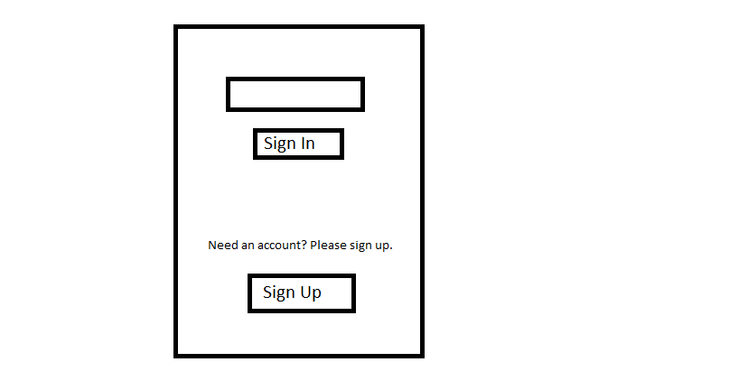

‘Sign up’ and ‘Sign In’ are two buttons that require touch by user. When you click ‘Sign Up’, you get:

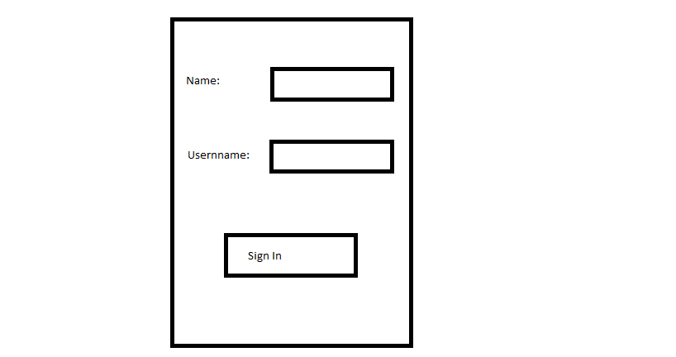

You need to sign up by providing information in the form of some text, which is a functional requirement.

On clicking ‘Sign In’, you will get something like this:

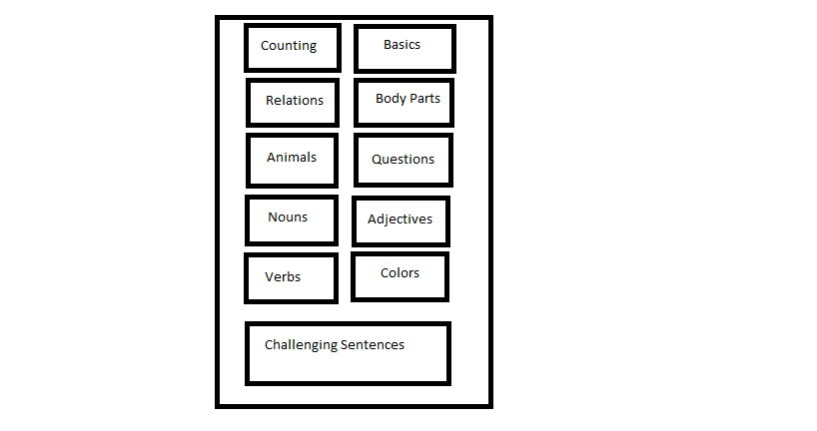

In this way, use of Buttons and Text is really important for the app to work.

**3.2.2Hardware Interface**

There is no such hardware interface required except that the user must have a ‘Smart phone’.

**3.2.3Software Interface**

Operating System of the smart phone should be any recent version of Android.

User will need about 80 MB free space in order to install this app.

**3.2.3Communication Interface**

In order to download it from internet, user must have internet access.

**3.3Performance Requirements**

Following are the performance requirements.

* A new window should appear within 5 seconds, whenever a button is pressed.
* Dialogue boxes should appear within 5 seconds, whenever a word is pressed.
* Check for validity of a username should be within 20 seconds.

**3.4Attributes**

* ***3.4.1 Availability***

This application will be available as long as user has his android smartphone.

* ***3.4.2 Security***

No password will be used in this app. Instead, each user will be given a unique username that will be used to login into the app. whenever a user chooses a username, a check for validity will be carried out, to make sure that the chosen username is unique.

* ***3.4.3 Maintainability***

Not required.